Vehicle guidelines and clearances

**Warning:**

**This document is restricted.**

**Copying and/or unauthorized distribution will lead to disciplinary action.**

The following document will act as a guide to show which department ranks will have access to vehicles within Site: Orno.

Said Ranks will also be required to be verified by a member of the Logistics Department in order to gain a Drivers's License.

Members within the Logistics Department with the rank of Inventory Manager+ will be able to grant Driver’s Licenses.

**Engineering & Technical:**

The following ranks within this department will have access to vehicles in-game.

Assistant Technician+ [Level-1]

E&T Clearance Sheet for reference:

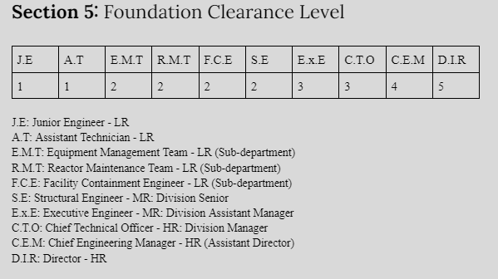

**Security Department:**

The following ranks within this department will have access to vehicles in-game:

Junior Security Officers+ [Level-2]

**Mobile Task Forces:**

The following ranks within this department will have access to vehicles in-game:

Nu-7

Executive Officer

Taskforce leader

(Future Taskforces to be added)

**Logistics Department:**

The following ranks within this department will have access to vehicles in-game:

Delivery Driver+ [Level-2]

Aquiring a driver’s license

The process of aquiring a driver’s license is a quick process,

the following requirements must be met in order to retrieve a driver’s license:

The individual must pass an exam regaring vehicle regulations, afterwards they’ll be required to pass a driving test with a member of the Logistics Department holding the rank of Inventory manager or higher supervising them.

Afterwards the student will be given their driver’s license if they’ve met the requirements with a good enough score.

The exam can take up to 24 hours depending on students waiting for their driver’s license and available supervisors.

**Signatures:**

**Director of on-site operations:**

***Pw3g***

**Administrator:**

***Snoopanium***

**Disclaimer:**

**Document is subject to change as we progress.**